Ms. Rossi

Honors Art 3 Figure Drawing Unit:

Artist: Leondardo Da Vinci
Assignments: You complete each at your own pace as long as all are completed by due date.
- Written assignment Vitruvian man (ideal Proportions)
- Anatomy reading, bone study
- ½ page negative shape drawing of ribcage/ ½ page contour of skull
- Human skeleton from life in sketchbook (full page) proportion shaded in pencil
- Skeleton Study close up section on colored paper (Chalk pastels or Charcoal)
- 10 gesture drawings of partner (weight, movement, line quality) in sketchbook
- Portrait of a classmate/friend in charcoal on butcher paper

Resources/ sites: http://thevirtualinstructor.com/gesturedrawing.html
http://www.projectarticulate.org/lessons/gestureFigureDrawing.pdf
http://www.youtube.com/watch?v=hFjn_onIXGY
http://www.alienthink.com/inventiontocompletehumanbeing.blogspot.html

Drawing Lessons, Human Anatomy and Renaissance Art
Many forms of creative expression can’t be broken down into bite sized chunks but Renaissance artists gave us many mathematical and scientific principles that we can use to help us do a better job of drawing the human form. We learnt many things from Renaissance artists that are still relevant today, from facial proportions and muscular and skeletal structure to shading techniques like crosshatching and chiaroscuro, so there’s much to be learned from delving into the history of Renaissance art.
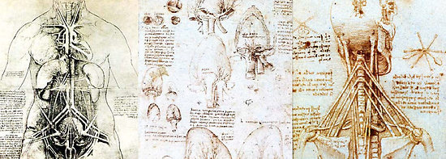
_{Studies by Leonardo Da Vinci}
Many Renaissance artists were also trained physicians and it was a time when the lines between art and science were often blurred. The most famous examples of the Renaissance study of the human form are Leonardo Da Vinci’s anatomical studies, but if you’re interested in finding out more about the history of anatomy and art, it’s also worth looking at the work of Andreas Vesalius. Vesalius also dissected human bodies (in a time when it was illegal) in order to find out more about human anatomy. He produced incredibly detailed drawings which were used to teach anatomy.
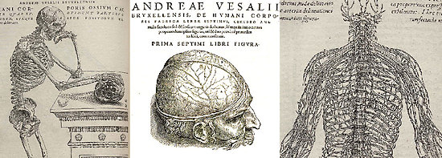
_{Studies by Andreas Vesalius}
Practice: The following tutorials have their origins in the principles that were discovered and practiced by artists during the Renaissance. If you’re interested in exploring rules that can be applied to improve your portraits and drawings of the human form, here are a few tutorials to get you started.
- Drawing hands and feet
- Tips for drawing hands
- How to draw a realistic eye
- Nose Drawing – Easier than it Looks
- Drawing Faces (Video) – Great info on proportions
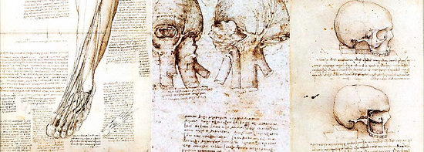
_{Studies by Leonardo Da Vinci}
Theory and Further Reading: If you’d like to do more reading on this subject, here are a few articles to kick start your investigations. If the subject intrigues you, a Google search will reveal even more.
- An Introduction to the Basics of Renaissance Art
- The Art of Renaissance Science
- The fine art of anatomy
- Anatomy in the Renaissance
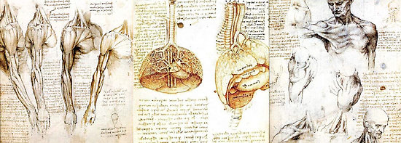
_{Studies by Leonardo Da Vinci}
Helpful video
http://www.youtube.com/watch?v=hFjn_onIXGY
